Identification and PID Control with different Tuning Methods for pH Neutralization Process

SUMMARY

pH neutralization control has been widely used in several chemical industries and more important in wastewater treatment areas. For example, the HCl production industry uses neutralization process to control the pH of wastewater so that it does not have impact over the environment when discharged. it is difficult to control pH process with adequate performance due to its severe nonlinearity, sensibility to small disturbance and time varying characteristics. Hence, more reliable, accurate, efficient, and flexible control techniques are required for pH neutralization. Studies on pH control in engineering have shown a dramatic increase in the last decades. pH control systems were developed and used successfully on various applications of pH process plants in many industries especially in chemical processes, biotechnological industries, wastewater treatment. The pH process is considered as a benchmark problem. Thus, the research is ongoing on identification and control in pH process. In this paper, aim is design PID controller with different tuning methods for pH Neutralization process. The mathematical model has been developed for a process. It was controlled by using conventional PID controller with parameters tuned by different tuning methods. The PID controller is designed using different tuning methods Tyreus Luyben, Cohen Coon, Ziegler Nichol, ITAE-Disturbance. The performance analysis is done for PID controllers in Acid, Neutral and Base region by keeping set point in 5, 7 and 9. The simulation results obtained by PID control algorithms are discussed. Controlling of pH in neutral region is an important and difficult process as small change in input gives the huge change in the output.

**Keywords:** pH Process, pH neutralization, PID controller, tuning methods, Ziegler Nichols, Tyreus Luyben, Cohen Coon, ITAE-Disturbance

1. **INTRODUCTION**

Now a days in chemical industrial process, very large number of useless water comes out as pollutants, in which some of them are costly and difficult to treat. The chlorine alkali industry consumes large quantities of water and produces large volumes of wastewater from different stages of chlore production. The low efficiency of chemical operations and spillage of chemicals, cause a significant pollution hazard and make the treatment of discharged wastewater a complex problem [1]. The most important scope of wastewater treatment plant is to control effectiveness of this harmful wastewater. HCl presents some very serious environmental health and safety issues. It is very corrosive and effects skin and all organs. Waste comes from the HCL production industries is acidic. This wastewater has to be neutralized before discharge or reuse [2].  It is difficult to control the pH process with adequate performance due to its non-linearities, time-varying properties and sensitivity to small disturbances when working near the equivalence point. Therefore, more reliable, accurate, efficient, and flexible control systems are required for pH neutralization process [1].

The acid ionizes in water to give hydroxide ions. The base ionizes in water to give hydroxyl ions. In the neutralization process, the strong acid (HCl) reacts with the strong base (NaOH) to keep it in the pH region. Controlling of pH in neutral region is an important and difficult process as small change in input gives the huge change in the output [2]. Wastewater treatment is one of the most challenging pH control problems encountered in the chemical industry. The purpose of the chemical plant is to neutralize the waste product solution before discharging it to the environment [1]. The required pH value for effluent from a wastewater treatment unit is in the range 7-9. So, the pH value has to be controlled between 7-9 to get the required controlling of pH for the wastage coming out from process industries. pH above 9 and pH below 4 are considered as injurious wastage to the surroundings. pH is affected by the variation in acid and base flow. Input and Output flow affects the Level [3]. Control of pH neutralization process is more important part in following areas like wastewater treatment, precipitation and electrochemistry plants, chemical and biological reaction and production of pharmaceuticals, fermentation, and food production [4].

At room temperature, if the pH value is below 7 the solution has a higher concentration of hydrogen ions and thus the solution is acidic. The ionic product of H2O is given by HCl + NaOH🡺 NaCl + H2O and its pH neutral (pH=7). Since in pure water the concentration of H+ ion is equal to the concentration of hydroxide ion OH− any addition of H+ ion will make it acidic and OH− ion will make it base. The addition of H+ may be due to the addition of acids and acidic impurities to the water stream by the industries manufacturing acids or industries using acids in one or more of their manufacturing stages. Similarly, the OH− may be from the industries manufacturing alkalis such as KOH, NaOH, etc. and from those industries using alkalis in one or more of their manufacturing stages. So, in order to make the pH within specific limit the acidic water the alkaline should be added and vice versa [5,6].

The primary objective is to develop a dynamic nonlinear pH process model, based on physical and chemical principles that can represent the specific pH process. The accuracy of this model should be sufficient to allow the development of conventional control system through simulation for subsequent implementation. The pH neutralization process is modelled based on the reaction between strong basic solution (NaOH) and strong acidic solution (HCl) in Continuous Stirred Tank Reactor (CSTR).

A proportional integral derivative (PID) control is a most common control loop feedback mechanism widely used in industrial control applications. It has good clarity and it is easy to implement. A PID controller helps to bring down the difference between the process variable and the set point by outputting the response with the desired value [1]. PID controllers are composed of three parts and principal control effects. The proportional (P) action gives a change in the input (manipulated variable) directly proportional to the error signal. The integral (I) action gives a change in the input proportional to the integral of error, and its main purpose is to eliminate offset. The less commonly used derivative (D) action is used in some cases to speed up the response or to stabilize the system and it gives a change in the input proportional to the derivative of the error signal. The overall controller output is the sum of the contributions from these three terms. The general form of the PID controller is given below in equation (1-3) [7].

 Proportional (P) part (1)

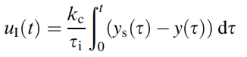 Integral (I) Part (2)

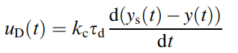 Derivative (D) Part (3)

The output of the PID controller is the sum of the above-mentioned three parts:

 (4)

where ${ y}_{s}(t), y(t)$ and $u(t)$ denote the setpoint (the desired process output), the process output and the control output of the PID controller, respectively. The constants $k_{C},τ_{i}$ and $τ_{D}$ are called the ‘proportional gain’, the ‘integral time’ and the ‘derivative time’, respectively.

As shown in (4), the PID controller is just a simple function of which the input is $y_{s}\left(t\right)-y\left(t\right)$ and the output is $u(t)$. It has excellent control performance and robustness. The PID controller has the three tuning parameters $k_{c},τ_{I}$ and $τ_{D}$, which should be set appropriately with in-depth consideration of the process dynamics [7].

The setpoint $y_{s}\left(t\right)$ and the parameters $k_{c},τ_{I}$ and $τ_{D}$ are set by the user. The process output *y $\left(t\right)$* is measured. Then, it is straightforward to calculate the output of the PID controller. The outputs of the integral part $u_{I}(t)$ and the derivative part $u_{D}(t)$ are usually calculated by the numerical integration method and the numerical derivative method respectively.

The input and the output of the PID controller are $y_{s}\left(t\right)-y\left(t\right)$ and $u\left(t\right),$ respectively. Then, the transfer function $(G_{C}\left(s\right))$ is

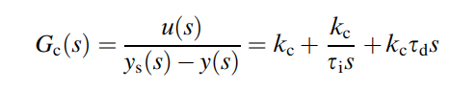 (5)

Three steps are used to implement the algorithm of the PID controller in computers.

1. It is read the process output from the sensor.

2. It is calculated the control output of the PID controller.

3. It is sent out the control output to the actuator.

In the second step, the integral part and the derivative part can be calculated by a numerical integration method and a numerical derivative method respectively. The Euler method and the backward difference method are used for the integral part and the derivative part respectively [7].

PID control Algorithm is given below:

1. It is read the present ( $kth$ sampling) process output $y(k)$ from the sensor.

2. It is calculated the controller output on the basis of the present and one-step-before data.

$u_{p}\left(k\right)=k_{C}\left(y_{s}\left(k\right)-y\left(k\right)\right)$ proportional part (6)

$u_{i}\left(k\right)=u_{i}\left(k-1\right)+\frac{k_{C}}{τ_{I}}(y_{s}\left(k\right)-y\left(k\right))∆t$ integral part (7)

$u_{d}\left(k\right)=k_{C}τ_{D}\frac{\left(y_{s}\left(k\right)-y\left(k\right)\right)-(y_{s}\left(k-1\right)-y\left(k-1\right))}{∆t}$ derivative part (8)

$u\left(k\right)=u_{p}\left(k\right)+u_{i}\left(k\right)+u_{d}\left(k\right)+u_{bias}$ control output (9)

**3.** Send the controller output to the actuator. When the time passes as much as the sampling time Δ $t$, repeat from step 1 with the k+1*-th* sampling.

Different methods have been proposed in this study to estimate the three parameters by performing a dynamic analysis experiment on the process.

**The Ziegler–Nichols tuning method** is a heuristic method of tuning a PID controller. It is one of the most popular method used in process control to determine the parameters of a PID controller. It is a trial and error method which is based on sustained oscillations. It also known as continuous cycling method [1]. It is performed by setting the I (integral) and D (derivative) gains to zero. The Proportional gain $k_{C}$ is then increased (from zero) until it reaches the ultimate gain $K_{u}$ at which the output of the control loop oscillates with constant amplitude [6]. The controller parameters are obtained using the ultimate gain $(K_{u})$ and ultimate period ${ (T}_{U})$ of oscillation. The ZN tuning rule shows acceptable control performances for the usual processes. However, because the ZN tuning rule uses only the ultimate data of the process, it shows poor control performances for underdamped or large time-delay processes, because the process has unusual frequency response characteristics in the low-frequency region [7].

Table 1 provides the tuning of parameters of PID controller for the obtained ultimate data set of the process [7].

**Integral of the Time-Weighted Absolute Value of the Error (ITAE) Tuning method** is the minimum error approach. It is used to develop controller design relation based on a performance index that considers the entire closed loop response [1]. ITAE tuning rule for a First-Order Plus Time-Delay (FOPTD) model provides the tuning parameters minimizing integral of the time-weighted absolute value of the error given by the Eq. 11 [7].

$ITAE=\int_{0}^{∞}{t\left|y_{s}\left(t\right)-y(t)\right|dt}=\int_{0}^{∞}{t\left|e(t)\right|dt}$ (11)

The parameters tuned by the ITAE-disturbance method for the step input disturbance rejection are almost the same as the optimal tuning parameters.

The Tyreus-Luyben method is also called as online closed-loop tuning method. This method is similar to Zeigler-Nichols as it uses ultimate gain and ultimate period. This closed-loop tuning method overcomes the shortcoming of the well-known Ziegler-Nichols continuous cycling method and gives consistently better performance and robustness for broad class of processes [10]. But when the value of dead time is large it gives a sluggish performance and the controller parameters are different [11,12] from Ziegler-Nichols as shown in Table 1.

**The Cohen-Coon method** is classified as an 'offline' method for tuning, meaning that a step change can be introduced to the input once it is at steady-state. Then the output can be measured based on the time constant and the time delay and this response can be used to evaluate the initial control parameters [12]. Cohen Coon method used process reaction curve method for calculating the parameters of PID controller and its tuning formula is given in Table 1.

Table 1. Tuning methods for PID parameters

|  |  |  |  |
| --- | --- | --- | --- |
| Tuning methods | $$k_{C}$$ | $$τ_{I}$$ | $$τ_{D}$$ |
| Ziegler Nichols (ZN) | $$K_{u}/1.7$$ | $${ T}_{U}/2.0$$ | $${ T}_{U}/8.0$$ |
| Tyreus luyben | $$K_{u}/2.2$$ | $${ T}_{U}* 2.2$$ | $${ T}_{U}/6.3$$ |
| ITAE- disturbance | $${kk}_{C}={1.357\left(\frac{θ}{τ}\right)}^{-0.947}$$ | $$τ/τ_{I}={0.842\left(\frac{θ}{τ}\right)}^{-0.738}$$ | $$\frac{τ_{D}}{τ}=0.381{\left(\frac{θ}{τ}\right)}^{0.995}$$ |
| Cohen coon | $$\frac{τ}{kθ}\left[\frac{(16+\frac{3θ}{τ}}{12}\right]$$ | $$\frac{θ(32+\frac{6θ}{τ})}{13+\frac{8θ}{τ}}$$ | $$\frac{4θ}{11+\frac{2θ}{τ}}$$ |

**2. MATHEMATICAL MODELING OF A NEUTRALIZATION PROCESS**

There are a lot of literature about pH model but the most widely accepted is McAvoy model for pH neutralization. Neutralization reaction of hydrochloric acid with sodium hydroxide that take place is the following

$$HCl+NaOH →H_{2}O+NaCl$$

$$H^{+}+OH^{-} →H_{2}O$$

Product of the neutralization process is water and salt.

The main idea for pH modelling is to calculate $X$ and then transform $X$ to hydrogen ions $H^{+}$ and after that from $H^{+}$ to pH. $X$ is the difference between molar concentration of hydrogen ions $H^{+}$ and hydroxide ions $OH^{-}$. Due to fact that the used chemicals are strong base and strong acid they are considered as completely dissociated.

The solution should remain electrical neutral. So, electro neutrality equation is

$\left[Na^{+}\right]+\left[H^{+}\right]=\left[Cl^{-}\right]+[OH^{-}]$ (12)

Re-arranging the Eq.12, $X$ is

$X=\left[OH^{-}\right]-[H^{+}]$ (13)

The *H+* balance equation and the OH- balance equation are used in order to calculate $X$.

For the system equations are formed as:

*H+* balance equation is

$V\frac{dH^{+}}{dt}=F_{a}H_{in}^{+}-\left(F_{a}+F_{b}\right)H^{+}$ (14)

*OH-* balance equation is

$V\frac{dOH^{-}}{dt}=F_{b}OH_{in}^{-}-\left(F_{a}+F_{b}\right)OH^{-}$ (15)

where

$V$: volume of the solution

$F_{a}$: flow of the acid

$F_{b}$: flow of the base

Subtracting equations Eq.14 from Eq.15 and using Eq.13, a balance equation for $X$ is obtained

$V\frac{dX}{dt}=\left[OH_{in}^{-}\right]F_{b}-\left[H_{in}^{+}\right]F_{a}-X(F_{a}+F_{b})$ (16)

For simplicity equation 16 can be written as

$V\frac{dX}{dt}=k_{b}F_{b}-k_{a}F_{a}-X(F_{a}+F_{b})$ (17)

Where $k_{b}$ is molar concentration of hydroxide ions and $k_{a}$ is molar concentration of hydrogen ions. There are measured at units of moles per liter.

The last term on the right-hand site of the equation 17 is nonlinear. So, this equation needs to be linearized. The method of the linearization around operating point is chosen. The operating point is 7 $pH$ or $\overline{X}=0$ due to the fact that the task is to neutralize the solution. Also Fa is known because the characteristics of the disturbance are known. The choice of the OP should be close to the steady state point. Now linearization can be proceed

$$X= \overline{X}+ X^{Δ}$$

$$F_{b}= {\overline{F}}_{b}+F_{b}^{Δ}$$

$$F_{a}=\overline{F_{a}}+F_{a}^{Δ}$$

Where $\overline{X}$ is the operating point steady state value and $X^{Δ}$ is the difference from operating point (deviation). Also due to the fact that at steady state $\frac{dX}{dt}=0$

$0=k_{b}{\overline{F}}_{b}-k_{a}{\overline{F}}_{a}- \overline{X}({\overline{F}}_{a}+ {\overline{F}}_{b})$ (18)

Replacing these relationship in Eq.17

$$V\frac{d(\overline{X}+X^{Δ})}{dt}=k_{b}\left({\overline{F}}_{b}+F_{b}^{Δ}\right)-k_{a}\left(\overline{F_{a}}+F_{a}^{Δ}\right)-(\overline{X}+ X^{Δ})({\overline{F}}_{b}+F_{b}^{Δ}+ \overline{F_{a}}+F_{a}^{Δ})$$

$$V\frac{dX^{Δ}}{dt}= k_{b}{\overline{F}}_{b}-k_{a}{\overline{F}}_{a}- \overline{X}\left({\overline{F}}_{a}+ {\overline{F}}_{b}\right)-\left({\overline{F}}_{a}+{\overline{F}}_{b}\right)X^{Δ}+\left(k_{b}+\overline{X}\right)F_{b}^{Δ}-\left(k_{a}-\overline{X}\right)F_{a}^{Δ}-X^{Δ}(F_{a}^{Δ}+F_{b}^{Δ})$$

The part of this equation

$k_{b}{\overline{F}}_{b}-k_{a}{\overline{F}}_{a}- \overline{X}\left({\overline{F}}_{a}+ {\overline{F}}_{b}\right)=0$

and

$X^{Δ}\left(F_{a}^{Δ}+F_{b}^{Δ}\right)≅0$

So the linearized equation is

$V\frac{dX^{Δ}}{dt}= -\left({\overline{F}}_{a}+{\overline{F}}_{b}\right)X^{Δ}+ \left(k_{b}+\overline{X}\right)F_{b}^{Δ}- \left(k_{a}-\overline{X}\right)F_{a}^{Δ}$ (19)

The related measurement that is available at the system is pH. So, a relationship between $X$ and $pH$ should be defined.

Dividing Eq.19 by V the state space equation are obtained

$\dot{X^{Δ}}=-\frac{{\overline{F}}_{a}+ {\overline{F}}_{b}}{V}X^{Δ} +\frac{\left(k_{b}+\overline{X}\right)}{V}F_{b}^{Δ}-\frac{{(k}_{a}-\overline{X})}{V}{F_{a}}^{∆}$ and $y=X^{∆}$ (20)

The system formulated as

$\dot{X^{Δ}}=AX^{Δ}+B_{C}F_{b}^{Δ}+B_{D}F_{a}^{Δ}$ (21)

$y=CX^{∆}$ (22)

Where

$A= -\frac{{\overline{F}}_{a}+ {\overline{F}}_{b}}{V}$

$B_{C}= \frac{\left(k_{b}+\overline{X}\right)}{V}$ (23)

$B_{D}= -\frac{{(k}_{a}-\overline{X})}{V}$

$C=1$

To convert space-space equations to transfer function

$sX\left(s\right)=AX\left(s\right)+BU(s)$ (24)

$Y\left(s\right)=CX\left(s\right)+DU(s)$ (25)

If we rearrange equation Eq.20

$X\left(s\right)\left[sI-A\right]=BU(s)$

$X\left(s\right)={\left[sI-A\right]}^{-1}BU(s)$ (26)

Put Eq.26 in Eq.25

$Y\left(s\right)=C{\left[sI-A\right]}^{-1}BU\left(s\right)+DU(s)$ (27)

So,

$\frac{Y\left(s\right)}{U\left(s\right)}=C{\left[sI-A\right]}^{-1}B+D$ (28)

According to above equations, for our pH neutralization system,

$\frac{X\left(s\right)}{F_{a}\left(s\right)}=\frac{B_{D}}{s-A}$

$\frac{X\left(s\right)}{F_{b}\left(s\right)}=\frac{B_{C}}{s-A}$ (29)

$\frac{X\left(s\right)}{F_{a}\left(s\right)}=\frac{-0.01}{545.22s+1}$

$\frac{X\left(s\right)}{F_{b}\left(s\right)}=\frac{0.0247}{545.22s+1}$

The related measurement that is available at the system is pH. So a relationship between X and pH should be defined.

Using equation Eq.13

$X=\left[OH^{-}\right]-[H^{+}]$

$\left[H^{+}\right]= -X+[OH^{-}]$ (30)

$[OH^{-}]$ is also related to $[H^{+}]$ with

$\left[OH^{-}\right]=\frac{K_{w}}{[H^{+}]}$ (31)

Where $K_{w}$ is the self-ionization constant of the water and it is equal with

$K_{w}={10}^{-14}$

Replacing equation Eq.18 and Eq.19

$H^{+}= -X+[OH^{-}]$

$\left[H^{+}\right]= -X+\frac{K_{w}}{[H^{+}]}$

${\left[H^{+}\right]}^{2}+X\left[H^{+}\right]-K_{w}=0$ (32)

Solving this second order polynomial two solutions are obtained. Discarding the unrealistic one the relationship between $X$ and $[H^{+}]$ obtained

$\left[H^{+}\right]=\frac{-X}{2}+ \sqrt{\frac{X^{2}}{4}+K_{w}}$ (33)

**3.MATERIAL and METHOD**

Neutralization reaction is the process in which an acid reacts with a base to produce salt and water. In this reaction, both the acid and base loose their properties to produce a new substance which is neutral in nature, the salt formed will neither be acidic nor basic. The preparation of sodium chloride involves the neutralization reaction between hydrochloric acid and sodium hydroxide. The acid and base react to produce sodium chloride (salt), water. The reaction is represented by the following equation: HCl + NaOH → NaCl+ H2O

For the experimental studies, an acid stream (HCl solution) and an alkaline stream (NaOH) with 0.0227 normality is fed to a 2 liters constant volume stirrer tank and the pH is measured through pH transmitter (glass electrode) which is placed at the tank. The pH is picked up with the aid of a probe placed into the mixing vessel close to the outlet. It can be emptied by a draining pipe that can be controlled by a valve. To make the mixture homogeneous, a variable speed mixer or stirrer is used.

The main objective of the system is to maintain the specific pH value by variations in base flow rate and keeping the acid flow rate at a constant level. Experimental apparatus are shown in Figure 4.

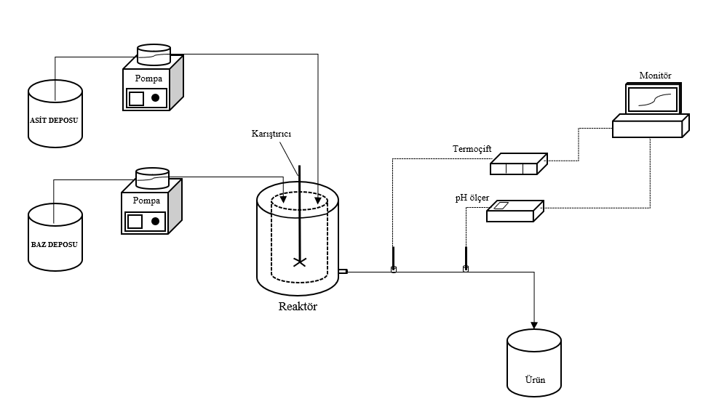

Figure 4. Experimental set-up

In order to carry out the process in optimum operating conditions, a stirred continuous stirrer reactor was used, and pH control was done with MATLAB Simulink program.

PC

Sensor

Pumps

RS232 to

RS485

ADC

DAC

Figure1. Serial Communication Flow Diagram

The communication between the sensor, the pump and the computer is provided by serial communication over the RS232 port on the computer. The communication between Matlab and the COM Port on the computer is carried out with matlab functions. Digital to Analog Converter is used to send a signal from the computer to the pumps, and Analog to Digital Converter is used to detect the Sensor data by the computer. Since ADC and DAC devices use the RS485 protocol, a RS232 to RS484 converter is used. The flow chart for the described processes is given in Figure1.

The pH neutralization system consists of two liquid streams acid and base, one feeding the acidic substance and the other feeds the base liquid. A special peristaltic pump at the rate of 40 ml/min is used to send acid to the vessel. The added Acid/base is mixed well using a mechanic stirrer that will be rotated at a speed of 300 rpm. Special type of pH probe is used to measure the pH inside the setup. In this experiment, strong acid (HCl) of 0.0091 molarity and strong base (NaOH) of 0.0227 molarity is prepared and used to conduct real-time experiments.

In this study, the pH neutralization process is modelled as a First Order Plus Delay Time model which is developed using state space equations. A comparative study of four different tuning methods for PID controllers using MATLAB, SIMULINK.

Mostly every system will have many objectives to be achieved. For designing a controller by satisfying all the requirements, algorithms are needed so as to tackle the problems that may arise. The conventional tuning methods which works based on fixed parameters will result in lesser performance when system necessitates controller. By using the above specified tuning methods can be determined the Proportional constant (C), Integral constant (I) and Derivative constant (D). This paper also includes Minimum Error Integral Criteria (ITAE, ISE and IAE) for determining the control performance. The time domain specifications and the performance index of different PID controllers were compared.

The simulation were done using MATLAB and SIMULINK. The pH neutralization PID control has been created in SIMULINK as shown in Figure 5 using the required blocks from the Simulink Library in MATLAB. (The step block parameters ; Step time = 0.5, initial value = 7, final value = 5,7 and 9). In the control studies, the PID control parameters calculated using the adjustment formulas given in Table 1 were used.

From Eq.29 transfer function were obtained and given below;

Transfer function = $\frac{0.0247 }{545.55s+1}$ (34)

The transfer function block parameters were set as: Numerator coefficients = [0.0247], Denominator coefficients = [545.55 1].

PID control parameters were calculated by using the X dependent transfer function which was obtained analytically and from Table 1.(bu hesaplarda KU(kapalı hat eş salınım K değeri, simulinkten 7000 olarak bulundu ve pid parametre hesaplarında bu değer kabul edildi. Gecikme ise 2 olarak alındı.)) Parameters calculated were given in Table 2 and they were used in simulation. The Simulink Block diagram for simulation were given in Figure 5.

Figure 5. Matlab Simulink Diagram for X dependent pH neutralization

**Table 2.** C,I,D values for different tuning methods

|  |  |  |  |
| --- | --- | --- | --- |
| Tuning methods | $$k_{C}$$ | $$τ_{I}$$ | $$τ_{D}$$ |
| Ziegler Nichols (ZN) | 4117.65 | 11.66 | 2.92 |
| Tyreus luyben | 3181.82 | 51.33 | 3.70 |
| ITAE- disturbance | 4671.88 | 20.30 | 1.94 |
| Cohen coon | 5896.44 | 12.26 | 1.82 |

**5. RESULTS AND DISCUSSIONS**

**5.1. Modelling Results**

The acid flow rate was kept at a constant level and a step change was given to the base flow rate. The computer is interface with the data acquisition and control and use the MATLAB Simulink to obtain the first order plus dead time transfer function model (Figure 7). The given step input and response of the system given in Figure 8 and Figure 9 respectively.

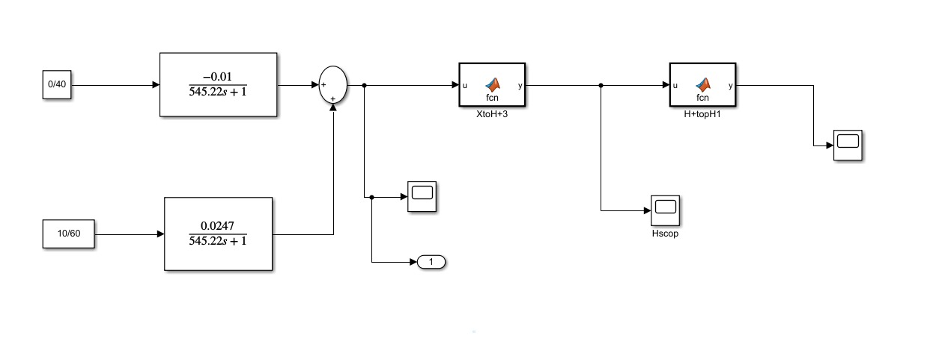

Figure 7. Simulink diagram to obtain process reaction curve theoretically

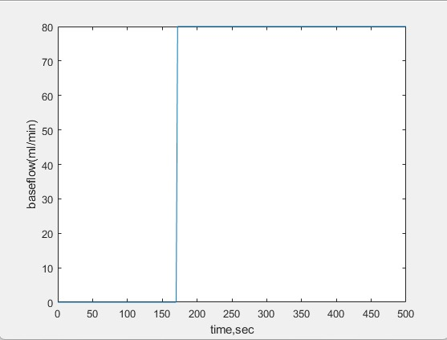

(a)

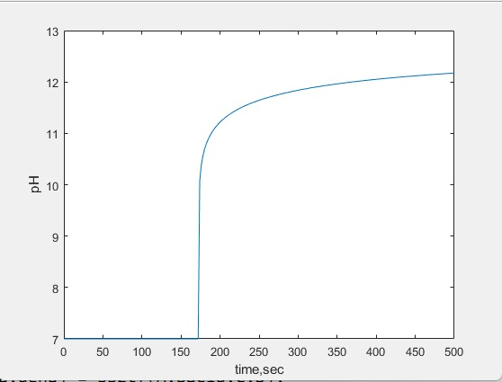

(b)

Figure 8. Step response of process identified by analytical transfer function calculated theoretically

(a) Step input

(b) System response

(a)

(b)

Figure 9. Experimental step response of process

(a) Step input

(b) System response

The transfer function model of the system obtained from the analytical model is

$G_{P}\left(s\right)=\frac{0.0247 }{545.55s+1}$ (35)

The initial stage of the study is to define the goal or the required specification, for the developed system at the end of the modelling process. This is to develop a pH process system which is adequate in terms of the intended application that is to design an improved form of the controller. It was decided that the simulation model has to be represent the behavior of the pH neutralization process with sufficient accuracy in terms of transient performance and steady state that commonly gives a basis for control system design. A general way of deriving dynamic equation for pH neutralization process in Continuous Stirred Tank Reactors was done.

We analyze and investigate the dynamic response of the laboratory plant and the corresponding behavior of the simulation model. We developed pH model and compared with experimental results. The reactor tank is filled with solution and the level was kept constant. The initial pH value of the solution in the reactor tank may be set to a desired value by controlling the two pomps for the acid and alkaline streams manually. We have given a step change of flow in the alkaline stream.

Figure 9 shows the dynamic response of the pH neutralization process for the experiment. In principle, in this experiment the initial pH should be set to the lowest possible value. However, the process to achieve the lowest pH value is quite time consuming as the reaction process in this region is very slow. In addition, it requires quite a lot of acid solution to bring down the pH value to the lowest value possible.

As shown in Figure 9, before the experiment started the pH value had been brought down, approximately, to the specified initial pH value of 3.6. At t = 300 second the process continues with the average flowrate for alkaline stream in the reactor tank being suddenly increased from zero to a steady value of 80 mL/min. Concentrations of solutions entered to the reactor were 0.0091 M acid and 0.0227 M the alkaline solution.

Figure 9 shows clearly the nonlinearity of the process through the operating range in terms of pH values. The dynamic response can be divided into three different regions with two different reaction rates as given in Table 3.

**Table 3.** Different region in step change of flow rate

|  |  |  |
| --- | --- | --- |
|  | **Range of pH Value** | **Reaction rate** |
| Acidic region | 4-6 | Low |
| Neutral region | 6-8 | High |
| Basic region | 8-10 | Low |

Computational work was carried out to simulate the experiment outlined above. The simulated experiments were based on the actual settings and configuration as given in Table 4.

**Table 4.** Parameter settings for the simulation work

|  |  |  |  |
| --- | --- | --- | --- |
| Concentration | | Step input cahange | |
| Acid | Base | Acid | Base |
| 0.0091 M | 0.0227M | 40 ml/min | 80 ml/min |

(Burada asit akış hızı 40 sabit, sapma değişkeni cinsinden 0)

The simulation result in terms of the dynamic response obtained from the developed model for experiment is shown in Figure 9. This simulated dynamic response is similar to the actual response obtained experimentally from the lab experimental system during the step response test, as shown in Figure 8 and 9.

**5.2. Control Results**

With the values of $k_{C}$, $τ_{I}$ and $τ_{D}$ in Table 2, step and regulatory response of the four different tuning methods obtained using MATLAB and SIMULINK are shown in Fig. 10-15. Time response parameters such as rise time, settling time and percentage overshoot obtained for different PID tuning techniques are summarized in Table 5.

From the SIMULINK simulation results, time domain specifications that is rise time, settling time, peak overshoot are calculated for different tunings methods of PID controller. The comparative analysis of controller performance based on the rise time, settling time, peak time, peak overshoot for the four methods are identified and listed in Table 6-7.

Investigation of ZN (closed loop)-PID, Tyreus Luyben-PID, ITAE-PID (disturbance), Cohen Coon-PID, controllers for laboratory scale pH neutralization process system is described in this section. For this investigation the acid (HCl) and base (NaOH) is fed in to the mixing tank and the flow is controlled through the control valve which is controlled by PID controller. Here the pH value of the effluent is maintained at pH 9 set value as shown in Figure 16-23.

Figure 10. Servo and regulatory Step response of PID controllers tuned Tyreus Luybben and ZN-CL in Acid Region (pH = 5)

Figure 11. Servo and regulatory Step response of PID controllers tuned Tyreus Luybben and ZN-CL in Neutral Region (pH = 7)

Figure 12. Servo and regulatory Step response of PID controllers tuned Tyreus Luybben and ZN-CL in Basic Region (pH = 9)

Figure 13. Servo and regulatory Step response of PID controllers tuned Cohen-Coon and ITAE-Dist in Acid Region (pH = 5)

Figure 14. Servo and regulatory Step response of PID controllers tuned Cohen-Coon and ITAE-Dist in Neutral Region (pH = 7)

Figure 15. Servo and regulatory Step response of PID controllers tuned Cohen-Coon and ITAE-Dist in Basic Region (pH = 9)



Figure 16. Experimental Resuts of PID controller tuned Cohen-Coon



Figure 17. Base pump flow rate PID controller tuned Cohen-Coon



Figure 18. Experimental Resuts of PID controller tuned ZN-CL



Figure 19. Base pump flow rate PID controller tuned ZN-CL



Figure 20. Experimental Resuts of PID controller tuned Tyreus Luyben



Figure 21. Base pump flow rate PID controller tuned Tyreus Luyben



Figure 22. Experimental Resuts of PID controller tuned ITAE-Dist



Figure 23. Base pump flow rate PID controller tuned ITAE-Dist

Table 5. Comparative performance metrics of Experimental PID control in Servo and Regulatory Control Problem

|  |  |  |  |  |  |  |  |  |  |
| --- | --- | --- | --- | --- | --- | --- | --- | --- | --- |
| Tuning Method | Set Point | Rise time (sec) | Peak time (sec) | Overshoot  (%) | Settling time (sec) | ISE | IAE | ITAE x ${10}^{6}$ | ITSEx ${10}^{6}$ |
| Ziegler Nichols (Closed Loop) | pH=9 | 474 | 1080 | 8.8 | 5300 | 12829 | 4731 | 7.2 | 6.8 |
| Cohen Coon | pH=9 | 451 | 1050 | 7.1 | 4600 | 10613 | 4247 | 6.4 | 6.0 |
| ITAEDIST | pH=9 | 684 | 1420 | 7.7 | 6000 | 15603 | 5412 | 8.5 | 9.2 |
| Tyreus Luyben | pH=9 | 1090 | 2200 | 5.5 | - | 29887 | 8006 | 13.7 | 20.1 |

From the SIMULINK simulation results, time domain specifications that is rise time, settling time, peak overshoot are calculated for different tunings methods of PID controller. The comparative analysis of controller performance based on the rise time, settling time, peak time, peak overshoot are identified and listed in Table 6 and 7.

In the design methodology of a PID controller, one of the most important performance criterion is the difference (error) between the plant output and the set point signal. Using this error criterion as the fitness function of the optimization algorithm results in a small overshoot with a long settling time. In general, fitness functions are based on error equations. The following four equations, integral time absolute error (ITAE), integral time square error (ITSE), integral absolute error (IAE), and integral square error (ISE) indicate the most commonly used fitness functions [13]:

$ISE=\int{e{(t)}^{2}.dt}$ (37)

$IAE=\int{\left|e(t)\right|.dt}$ (38)

$ITAE=\int{t.\left|e(t)\right|.dt}$ (39)

$ITSE=\int{t.\left|{e(t)}^{2}\right|.dt}$ (40)

The error indices like Integral Absolute Error (IAE), Integral Square Error (ISE) and integral time absolute error (ITAE) are also calculated and tabulated in Table 6 and 7 of the proposed system.

Table 6. Comparative performance metrics of PID control in Servo Control Problem

|  |  |  |  |  |  |  |  |  |  |
| --- | --- | --- | --- | --- | --- | --- | --- | --- | --- |
| Tuning Method | Region | Rise time (sec) | Peak time (sec) | Overshoot (%) | Settling time (sec) | ISE | IAE | ITAE | ITSE |
| Ziegler Nichols (Closed Loop) | Acid | 32.61 | 54.5 | 3.86 | 104 | 12 | 22 | 525 | 176 |
| Neutral | 32 | 48.50 | 22 | 161.5 | 251.98 | 140.27 | 5141 | 6618 |
| Base | 24.55 | 48.66 | 1.48 | 96 | 492 | 123.72 | 1887.1 | 6685.3 |
| Tyreus Luyben | Acid | 75.91 | - | 0 | 162 | 51 | 83 | 5410 | 2298 |
| Neutral | 220 | - | 0 | 300.54 | 924 | 461 | 47680 | 71132 |
| Base | 109 | - | 0 | 149 | 1989.2 | 486.5 | 27207 | 97813 |
| ITAE (disturbance) | Acid | 24.16 | 74.5 | 0.086 | 80.34 | 15.12 | 26.20 | 598.59 | 253 |
| Neutral | 38.55 | 93.5 | 1.71 | 151.1 | 290.5 | 142.19 | 4571.5 | 7484.8 |
| Base | 35.24 | 64.42 | 0.02 | 78 | 663.1 | 166.51 | 3289.1 | 11947 |
| Cohen Coon | Acid | 21.32 | 48.5 | 0.64 | 60.5 | 8.84 | 15.29 | 235.4 | 84.16 |
| Neutral | 31.58 | 47 | 12.36 | 105 | 170.77 | 94.44 | 2313.3 | 3029 |
| Base | 24.48 | 46.5 | 0.33 | 61 | 370.79 | 96.43 | 1154 | 4048 |

Table 7. Comparative performance metrics of PID control in Regulatory Problem

|  |  |  |  |  |  |  |  |
| --- | --- | --- | --- | --- | --- | --- | --- |
| Tuning Method | Region | Overshoot (%) | Settling time (sec) | ISE | IAE | ITAE | ITSE |
| Ziegler Nichols (Closed Loop) | Acid | 5.83 | 42.48 | 1.93 | 9.19 | 233.95 | 42.22 |
| Neutral | 24.14 | 86.90 | 125.84 | 93.70 | 3190.6 | 3242 |
| Base | 1.92 | 13.89 | 9.87 | 13.61 | 233.25 | 98.65 |
| Tyreus Luyben | Acid | 2.32 | 63.89 | 1.83 | 12.61 | 645 | 48 |
| Neutral | 19.63 | 202.71 | 214.56 | 186.51 | 14280 | 11660 |
| Base | 1.01 | 19.88 | 58.45 | 31.24 | 769 | 585 |
| ITAE (disturbance) | Acid | 3.76 | 44.02 | 1.41 | 8.22 | 211.78 | 27.76 |
| Neutral | 22.042 | 82.63 | 127.31 | 93.91 | 3108.3 | 3449.3 |
| Base | 1.44 | 14.14 | 15.51 | 15.20 | 242.99 | 149.5 |
| Cohen Coon | Acid | 4.36 | 34.52 | 1.1 | 6.32 | 126.95 | 18.905 |
| Neutral | 22.817 | 69.88 | 94.39 | 68.76 | 16944 | 1881.4 |
| Base | 1.60 | 12.16 | 2.87 | 8.06 | 122.08 | 27.53 |

Considering the results given in Figure 10-15, it was observed that, the simulation results using ZN-CL, Tyreus Luyben, Cohen Coon and ITAE-DIST methods were found to be in acceptable range. As can be seen from Table 6 among those methods, the simulation results using Tyreus Luyben had the highest settling time. In the neutral region, ITAE-DIST has the lowest overshoot with %1.71 and Cohen-Coon has the lowest settling time with 60.5 sec. Considering the error values indicated in Tables 6 and 7, it was seen that the ITAE-DIST and ZN-CL methods had close results for both servo and regulatory control, while the Cohen-Coon method had the best results.

The possible reason for this can be the fact that study was not done on …… tuning method. This confirms again that ……gives best results followed by ……. .

**6. CONCLUSION**

Controller tuning is adjustment of control parameters to the optimum values for obtaining the desired control response. Stability is a basic requirement. The most widely used simple feedback control strategy applied to pH control involves the PID algorithm. Adjustment of the PID settings should be performed to ensure some desired performance criteria.

* Closed-loop system must be stable,
* Rapid, smooth response is obtained
* Offset is eliminated
* Specific overshoot, decay ratio or rise time is obtained
* Excessive control action is avoided
* The control system is robust

This study makes a comparative study of the different tuning methods for PID control of pH neutralization in HCL production industry for a first order system. Total different PID tuning techniques were implemented, and their performances analyzed. Due to high non-linearity and instability of chemical process, the most optimum and desired controller system will be the one providing: Minimum settling time to reach the set point, reduced oscillations, short rise time, eliminate offset, minimum percent overshoot, high stability in the presence of noise signals and disturbances. Among the ten PID tuning techniques, Cohen Coon Method PID controller gives the best results for a first order system.

From the simulation results obtained, time domain characteristics are calculated for different tuning methods of Proportional Integral Derivative (PID) controller. The controlling of nonlinear system is a very challenging task to perform. In this work, model is obtained for pH process. By using obtained model, proper tuning values are obtained for different controllers. The pH value was controlled in simulation using various control schemes such as ZN (open loop) PID, ZN (closed loop) PID, Tyreus Luyben PID, ITAE PID (set point and disturbance), Cohen Coon PID controllers. The results suggested that Cohen Coon tuning formula gave least rise time and settling time with acceptable percentage of overshoot.

PID controller is designed using ten tuning methods and their performances are compared. It is shown graphically that the time domain specification in terms of peak overshoot and settling time are less in Cohen coon method. Error indices like Integral Absolute Error (IAE), Integral Square Error (ISE) and Integral of Time weighted Absolute Error (ITAE) of this method is also comparatively less. From the result it is identified that Cohen Coon method is better than other three tuning methods for pH Neutralization Process.

**REFERENCES**

1. Babu, R. and Swarnalatha R., 2017, Comparison of Different Tuning Methods for pH Neutralization in Textile Industry, ournal of Applied Sciences, 17 (3): 142-147, 2017

2. Ram S.S., Kumar D. D. and Meenakshipriya B. 2016, Indian Journal of Science and Technology, Designing of PID Controllers for pH Neutralization Process, Vol 9(12),1-5.

3. Garcia C, De Godoy RJC. Modelling and simulation of pH neutralization plant including the process instrumentation. Applications of MATLAB in Science and Engineering. 2011. p. 485–10.

4. Jose T, Antony R, Isaac S. pH Neutralization in CSTR using model reference neural network and fuzzy logic adaptive controlling schemes. International Journal of Advancements in Research and Technology. 2013; 2(1):1–6.

5. Ibrahim, R., 2008. Practical modelling and control implementation studies on a pH neutralization process pilot plant. Ph.D. Thesis, University of Glasgow, Scotland, UK.

6. Sharmila B., Vidhyanandhan L., 2016, Modelling and designing of controllers for pH process, Journal of advances in Chemistry, vol 12, No:15, 4872-4883.

7. Sung S.W., Lee J and Lee I.B., 2009, Process Identification and PID control, John Wiley and Sons, 1st ed.

8. Parr E.A., 1995, Industrial Control Handbook, Butterwort and Hainemann, 2nd ed., 608-610.

9. Selvi,S.V., Priyadharsini, S., Priya, D.R. and Aravind,P.2014.Application of various PID Controller Tuning Techniques for a Temperature System.International J.of Computer Applications. 103 (Oct.2014),32-34.

11. Anusha,S., Karpagam,G. and Bhuvaneswarri,E.2014.Comparison of tuning methods of PID controller. International J.of Management, Information Technology and Engineering. 3 (Aug.2014),1-8.

12. Bequette B.W., 2003, Process Control, Modelling, Design, and Simulation, Prentice Hall of India,1 st ed., 198-202.

13. Stephanopoulos G.,1984, Chemical Process Control, An introduction to theory and practice, Prentice Hall, 1 st ed.,298-355

14. Rao M. and Qiu H., 1993, Process Control Engineering, Gordon and Breach Science Publishers, 86.

**Şekil 21-23 grafikleri için dosya isimleri**

degerler1 = xlsread('XdependCohenCoon.xlsx');

degerler2 = xlsread('XdependZNCL.xlsx');

degerler3 = xlsread('XdependITAEDIST.xlsx');

degerler4 = xlsread('XdependTyreus.xlsx');

time1 = degerler1(:,1);

y_set1 = degerler1(:,3);

y1 = degerler1(:,2);

u1 = degerler1(:,4);

time2 = degerler2(:,1);

y_set2 = degerler2(:,3);

y2 = degerler2(:,2);

u2 = degerler2(:,4);

time3 = degerler3(:,1);

y_set3 = degerler3(:,3);

y3 = degerler3(:,2);

u3 = degerler3(:,4);

time4 = degerler4(:,1);

y_set4 = degerler4(:,3);

y4 = degerler4(:,2);

u4 = degerler4(:,4);

figure(1)

plot(time1,y_set1,time1,y1);

title('CohenCoon')

figure(2)

plot(time1,u1)

title('CohenCoon u')

figure(3)

plot(time2,y_set2,time2,y2)

title('ZNCL')

figure(4)

plot(time2,u2)

title('ZNCL u')

figure(5)

plot(time3,y_set3,time3,y3);

title('ITAEDIST')

figure(6)

plot(time3,u3)

title('ITAEDIST u')

figure(7)

plot(time4,y_set4,time4,y4);

title('TyreusLuyben')

figure(8)

plot(time4,u4);

title('Tyreus u')